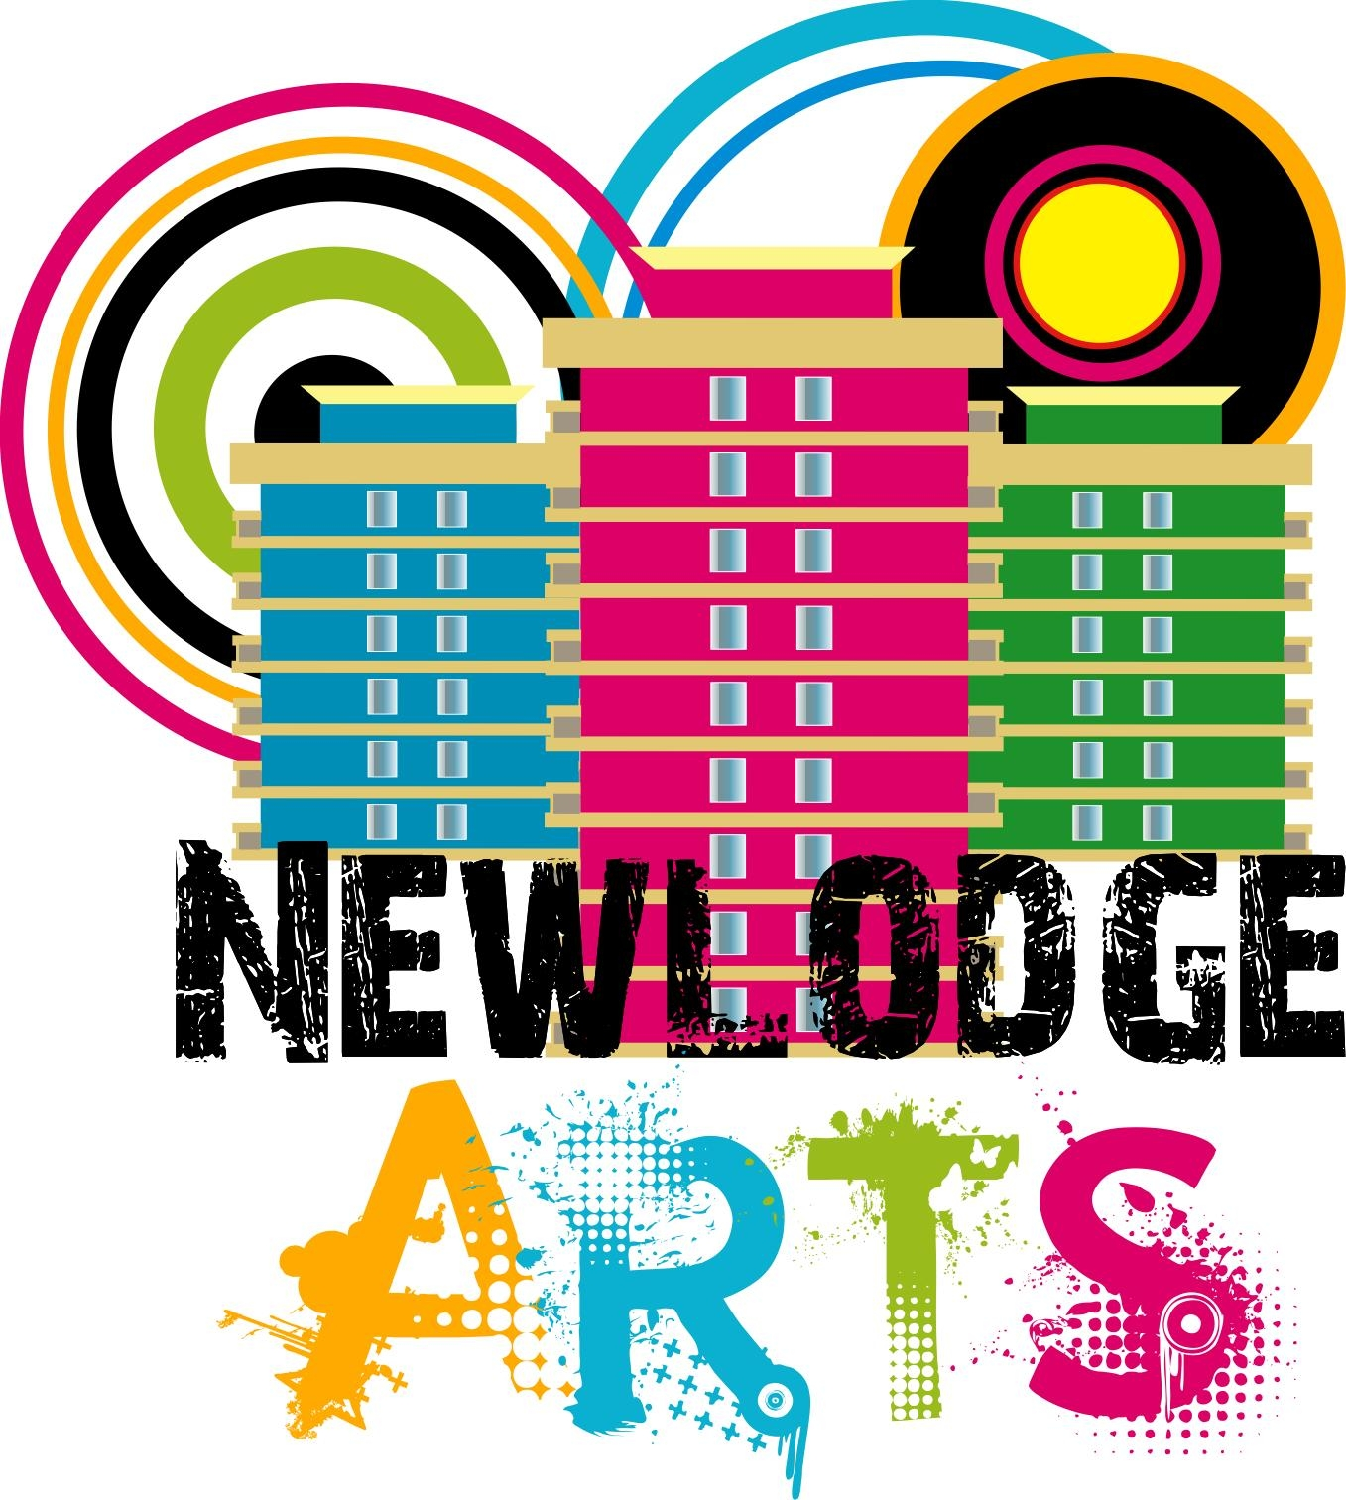

Recruitment Pack
Recording Studio – Digital Engineer

The deadline for applications is 12noon on Wednesday 10th July 2024.

Under no circumstances will late applications be considered.

You can either complete this form online:

https://forms.gle/CyPDPtGTDx9bx2cs5

Or complete the form below and email to:

anne.delaney@ashtoncentre.com

This programme is funded by The National Lottery Fund Dormant Accounts.
Specification

Role: The Studio – Digital Engineer

Hours: Minimum of 15 hours per week

Fee: £300 per week

Responsible to: Arts Programme and Operations Manager, New Lodge Arts

Location: New Lodge Arts, Ashton Centre

Job Background:

New Lodge Arts would like to develop its Studio Space in to a digital space for artists and creatives. Whether an aspiring artist, a rising star, or a seasoned professional, from within the local community or from further afield, we aim to provide a space where music and visuals matter; a space for music production, mixing and online mixing, voice recording and podcasting, photographic and video editing. We will bring artists and audiences together through live experiences and artist services that inspire creativity, community and joy. Our supportive and unique live experiences will provide a place for artist discovery, local community and connection in non-traditional, unexpected places. The Studio will provide a space for participants of our creative community programmes and a service for clients wanting to hire the space, with support from a Digital Engineer.
We are looking for a competent Digital Engineer to play a lead role in the development and delivery of The New Lodge Arts Studio. This key role will oversee and lead the business development aspect of The Studio ensuring growth, sustainability and resilience, boosting New Lodge Arts’ capacity to be more adaptable and strategic, so that we may create more sustainable services delivering long-term, positive outcomes for all stakeholders.
This role will also oversee daily operations of The Studio, to include supporting programme participants and paying clients to record, mix and edit music and audio as well as digital imagery and film. The post holder will set up and operate sound equipment in live events, recordings or post-productions to ensure the best acoustic result.

Job description

The Studio Development
Lead on the development of The Studio to include installation, set-up and provision of resources
Develop successful partnerships with organisations and individuals from across the community including voluntary, public and community organisations, schools, youth clubs and other arts organisations that will support the work of The Studio
Lead on the development and delivery of community-based programmes, responsible for the recruitment and retention of participants
Manage The Studio by making bookings on behalf of clients and ensuring that the space booked is adequately prepared for each client
Provision of audio editing and sound recording to include set up and testing of sound equipment before events, broadcasts or recordings; record, edit and mix audio tracks (instruments, vocals etc.), etc.
Resolve technical issues when they arise
Be responsible for the monitoring and management of The Studio

Business Development
Support the Operations Manager with individual funding application processes; funding proposals, contract tenders, etc.
Actively seek out and pursue new opportunities and sources of income to include partnerships, fundraising, corporate sponsorship, legacies, grants and contracts/sub-contracts and charging for The Studio services.
Work with the Operations Manager, Business Support mentor and relevant colleagues to ensure Strategic Plan objectives and Business Priorities are achieved.
To strengthen our relationships with existing strategic partners to work collaboratively in accessing new funding to enhance and innovate services for the local community.

Administration and Communication
To ensure effective and comprehensive administrative systems are maintained and communication materials distributed
Utilise office systems to ensure thorough planning, tracking and evaluation of projects is achieved
Organise marketing and publicity material for The Studio, working with the Operations Manager and Business Support Mentor

Creative Development and Delivery
To create innovative and engaging outreach work to develop The Studio reach
Support the development of artists
Be forward thinking in generating and deploying new ways of reaching and working with a diverse range of people
Take a leadership role in the delivery of workshops, training and production sessions
Work collaboratively with The New Lodge Arts’ team in developing new and exciting methods to engage people in The Studio

General
To maintain knowledge and communication for the effective delivery of the project
Keep up to date with developments within music production, audio recording and digital arts
Represent New Lodge Arts Studio at external events as required
Respect and adhere to the Health & Safety policy, undertaking duties as required and ensuring that reasonable care is taken to maintain a healthy and safe place for public and staff
Actively committed to the Equal Opportunities policy and Safeguarding policies

Organisation
To ensure company policies and procedures are met and all activity undertaken is legally compliant
As the post will require handling, processing and recording of restricted information, confidentiality is required to be maintained at all times
Comply with all Policies and statutory regulations
Any other duties as and when required

Person Specification

Essential Criteria

Qualifications and Training
3rd level qualification in a relevant discipline (audio/sound engineering or related field) AND two years’ experience of working within a similar role
OR
Have a minimum of 5 years’ experience of working within a similar role
Evidence of further professional development and training and how it has been applied

Experience
Proven experience working with a range of stakeholders as a sound/ digital engineer
Technical expertise in sound engineering techniques (e.g. equalization)
Experience with sound/ digital editing and recording
Working knowledge of recording software and hardware (e.g. Pro Tools)
Experience of fundraising and/or tendering
Securing and/or managing income generating activity
Experience of delivering creative participatory projects
Marketing and Communication

Knowledge, Skills and Abilities
Proficient IT skills including Microsoft Office software, Mac hardware, internet & email.
A team player with excellent communication, presentation and interpersonal skills
Creativity and Solution Focused Approach to problem solving
Problem-solving abilities
Knowledge of the community and social enterprise
Effective time management skills with the ability to co-ordinate multiple projects

Personal Attributes
Ability to self-evaluate and reflect on work practice
Ability to adapt to changing circumstances and new ideas
Ability to establish and maintain positive working relationships people at all levels
Ability to work flexibly in response to opportunities and deadlines
Enthusiasm for delivering a variety of exciting digital media activities
An understanding and vision of how the arts can provide positive benefits for the community and people with different needs and abilities.
Availability to work evenings and weekends.

Desirable Criteria
Experience
Experience of working with young people who may have complex needs or challenging behaviour.

We encourage applications from all parts of the community.

Any applications not including all information above will be discounted as incomplete and will not move to scoring. All applications must be received no later than 12.00 pm on Wednesday 10th July 2024.

Application for Recording Studio – Digital Engineer

Employment Application Form Application Number:

Please complete this application form in black ink or typescript and return it on or before the closing date stated. Late applications will not be accepted. Only information provided on this application form will be considered by the panel. CV’s will not be accepted.

Post applied for: | Recording Studio – Digital Engineer
Hours: | 15 hours per week (times to be agreed)
Closing Date and Time: | Wednesday 10th July 2024 @ 12noon

Personal Details:
Surname: | Telephone Number (Home):
Forename(s): | Telephone Number (Mobile):
Title: | Email Address:
Address: | Postcode:
NI Number:

Relevant Qualifications and/or Professional Membership
Original proof of qualifications will be requested if recommended for appointment
(Please continue on a separate sheet of necessary)

Examination level  (for example, GCSE/’A’ Level/Degree/NVQ | Subject(s) | Grade | Date Gained
Professional Qualifications | Registration Body/Number |  | Date Gained

Employment History

Please give details of jobs that you have held, starting with your present or most recent employer and work backwards, in chronological order. Include in this section any breaks in employment history for example, caring responsibilities, travelling or returning to study, registered unemployment and temporary/voluntary employment. (Please continue on a separate sheet if required)

Name and Address of Employer and Nature of Business | From | To | Job Title: | Final Salary and Reason for Leaving
Notice required if offered the position for which you have applied?

Training

Details of relevant training courses attended and awards achieved, including dates if appropriate

Suitability for this position

Please detail your suitability for this position under the relevant headings below, describing how your experience and knowledge relates to the job description and person specification. You must ensure that you provide sufficient information on the application form to enable the selection panel to assess your eligibility at shortlisting.

  - Please demonstrate your qualifications and training relevant to this role.

2. Please demonstrate to the panel your experience of working in a similar role to include:
- Proven experience working with a range of stakeholders as a sound/ digital engineer
- Technical expertise in sound engineering techniques (e.g. equalization)
- Experience with sound/ digital editing and recording
- Working knowledge of recording software and hardware (e.g. Pro Tools)

3. Please demonstrate your experience of Business Development to include
- Experience of fundraising and/or tendering
- Securing and/or managing income generating activity

4. Please demonstrate your experience of delivering creative participatory projects.

I confirm that the information I have given is accurate and complete, as misleading or false statements will result in the withdrawal of the offer of employment, or if employed dismissal.

Signed…………………………………………………Date…………………………………..

New Lodge Arts is an Equal Opportunities Employer. The organisation encourages applications from people with disabilities and will not preclude full consideration of your application as a result of your disability. In accordance with the Disability Discrimination Act a person is disabled if they have, or have had, “a physical or mental impairment which has, or has had, a substantial and long-term adverse effect on their ability to carry out normal day-to-day activities”.

Do you consider yourself to have, or, have had a disability that is relevant to your job application? Yes/No

If you have answered yes, is there anything we should know about your disability or requirements in order to:
- Process your application fairly,
- Make any specific arrangements for your interview, and
- Make any necessary reasonable adjustments or adaptations, or provide any aids to assist you in completing the duties of the post.

Provide details:

Referees
Please give full details of two people (not relatives) that we can approach for references, one of which must be your current or most recent employer, if you have never been employed before please list details of someone who would know you in a voluntary or academic capacity. Please ensure that your referees are aware of this application, and, also, if you are providing us with their email address, that you obtain your referee’s permission to do so. References must be satisfactory to New Lodge Arts.

Reference
Name:
Occupation:
Full Address:
Telephone Number:
Email:

Reference
Name:
Occupation
Full Address:
Telephone Number:
Email:

Prior to award of role, the following will be required:

• Proof of eligibility to work in the UK

• ACCESS NI check will be conducted if successful.

New Lodge Arts complies with Access NI Code of Practice, which can be downloaded from https://www.nidirect.gov.uk/sites/default/files/publications/accessni-code-of-practice.pdf

